The Pulse Check
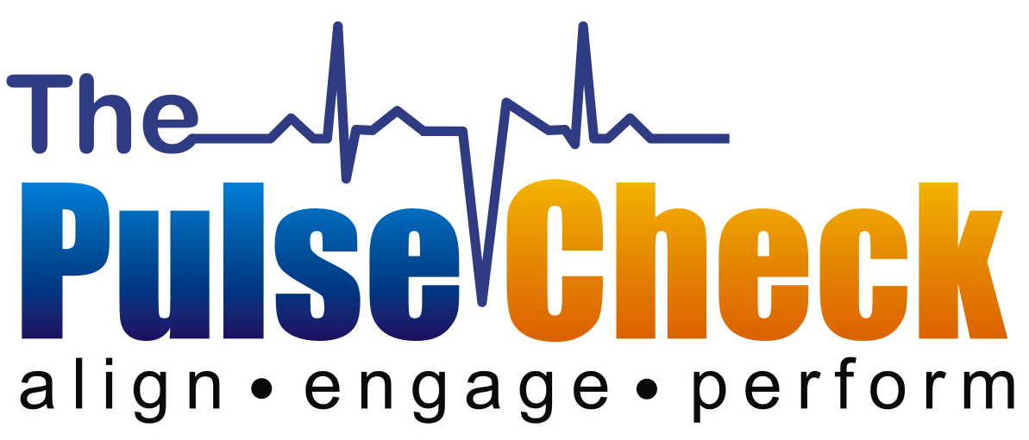

Goal Planning Template

Employee Information
Employee Name: | Employee ID:
Job Title: |  |  | Department:
Supervisor:
Date: |  | Review Period: |  | to

Instructions
Goals should always be: S – Specific M – Measurable A – Achievable R – Relevant T – Time Bound

- Specific & strategic. Linked to position summary, departmental goals/mission, and/or overall organizational goals and strategic plans. Answers the question—Who? and What?
- Measurement. This answers the question how. How will the goal/objective be evaluated? (Use quantitative measures such as % or dollar increase in revenue or market share and/or use qualitative measures which are descriptive of criteria.)
- Ambitious but attainable. Establishing targets that have a stretch element is critical to both individual development and organizational performance.
- Relevant (results oriented). The goals are aligned with current tasks and projects and focus in one defined area; include the expected result.
- Time Bound. Goals have a clearly defined time-frame including a target or deadline date.
- Importance. Rank the goal as Essential, Important, or Desirable as follows:
Essential – required for job performance
Important – helpful for job performance
Desirable – asset for job performance

My 1st Goal/Objective
Description:

Measurement: How will we know I’ve successfully achieved this goal?

Relevance: How does this goal relate to my role?

Time frame for completion: When do I expect to complete this? What are the significant milestones?

Importance: Essential Important Desirable

My 2nd Goal/Objective
Description:

Measurement: How will we know I’ve successfully achieved this goal?

Relevance: How does this goal relate to my role?

Time frame for completion: When do I expect to complete this? What are the significant milestones?

Importance: Essential Important Desirable

My 3rd Goal/Objective
Description:

Measurement: How will we know I’ve successfully achieved this goal?

Relevance: How does this goal relate to my role?

Time frame for completion: When do I expect to complete this? What are the significant milestones?

Importance: Essential Important Desirable

Resources Required
My 1st Goal/Objective:

My 2nd Goal/Objective:

My 3rd Goal/Objective:

My Commitment

Signature: ______________________________ Date: ________________________

